--Customer table

CREATE TABLE Customer

(

Id int primary key not null,

FirstName nvarchar(40),

LastName nvarchar(40),

City nvarchar(40),

Country nvarchar(40),

Phone nvarchar(40)

);

--index of customer table

CREATE INDEX IndexCustomerName

ON Customer(FirstName, LastName);

--Orders table

CREATE TABLE Orders

(

Id int primary key not null,

OrderDate datetime not null,

OrderNumber nvarchar(10),

CustomerId int foreign key references customer(Id),

TotalAmount decimal(12,2)

);

--index of Order table

CREATE INDEX IndexOrderCustomerId

ON Orders(CustomerId);

create index IndexOrderDate

ON Orders(OrderDate);

--Product table

CREATE TABLE Product

(

Id int primary key not null,

ProductName nvarchar(50),

UnitPrice decimal(12,2),

Package nvarchar(30),

IsDiscontinued bit

);

--Index of Product table

create index IndexProductSupplierId

ON Product(Id);

create index IndexProductName

on Product(ProductName);

--OrderItem table

CREATE TABLE OrderItem

(

Id int primary key not null,

OrderId int foreign key references Orders(Id),

ProductId int foreign key references Product(Id),

UnitPrice decimal(12,2),

Quantity int

);

--index of OrderItem

CREATE INDEX IndexOrderItemOrderId

on OrderItem(Id);

CREATE INDEX IndexOrderItemProductId

on OrderItem(ProductId);

--decribing Customer table

exec sp_help 'dbo.Customer';

--decribing OrderItem table

exec sp_help 'dbo.OrderItem';

--decribing Orders table

exec sp_help 'dbo.Orders';

--decribing Product table

exec sp_help 'dbo.Product';

--Inserting record in Customer table

INSERT INTO dbo.Customer VALUES(1, 'suresh', 'hande', 'kamothe', 'india', 9920851993);

INSERT INTO dbo.Customer VALUES(2, 'sadhana', 'hande', 'kharghar', 'canda', 9870060986);

INSERT INTO dbo.Customer VALUES(3, 'pragati', 'hande', 'belapur', 'USA', 9870060982);

INSERT INTO dbo.Customer VALUES(4, 'pooja', 'hande', 'seawoods', 'london', 9619066943);

INSERT INTO dbo.Customer VALUES(5, 'pranjal', 'hande', 'nerul', 'america', 9076460291);

INSERT INTO dbo.Customer VALUES(6, 'priya', 'hande', 'downtown', 'Japan', 9321428802);

--displaying records from Customer table

SELECT *FROM Customer;

--Inserting record in Orders table

INSERT INTO Orders VALUES(11, 21-01-2022, 10, 1, 11);

INSERT INTO Orders VALUES(22, 21-02-2022, 21, 2, 22);

INSERT INTO Orders VALUES(33, 21-03-2022, 32, 3, 33);

INSERT INTO Orders VALUES(44, 21-04-2022, 43, 4, 44);

INSERT INTO Orders VALUES(55, 21-05-2022, 54, 5, 55);

INSERT INTO Orders VALUES(66, 21-06-2022, 65, 6, 66);

--displaying records from Orders table

SELECT *FROM Orders;

--Inserting record in Product table

INSERT INTO Product VALUES(1111, 'study table', 5500.65, 'courier', 1);

INSERT INTO Product VALUES(2222, 'laptop', 65000.90, 'home-delivery', 1);

INSERT INTO Product VALUES(3333, 'hard-disk', 8000, 'courier', 0);

INSERT INTO Product VALUES(4444, 'tv-cabinet',12500.65, 'delivery', 0);

INSERT INTO Product VALUES(5555, 'perfume', 790.22, 'courier', 1);

INSERT INTO Product VALUES(6666, 'sofa-set', 17000.25, 'home-delivery', 0);

--displaying records from Product table

SELECT *FROM Product;

--Inserting record in OrderItem table

INSERT INTO OrderItem VALUES(111, 22, 1111, 5500.65, 10);

INSERT INTO OrderItem VALUES(222, 33, 2222, 65000.90, 20);

INSERT INTO OrderItem VALUES(333, 44, 3333, 8000, 30);

INSERT INTO OrderItem VALUES(444, 55, 4444, 12500.65, 40);

INSERT INTO OrderItem VALUES(555, 66, 5555, 790.22, 50);

INSERT INTO OrderItem VALUES(666, 66, 6666, 17000.25, 60);

--displaying records from OrderItem table

SELECT *FROM OrderItem;

5. Display all customer details

SELECT *FROM Customer;

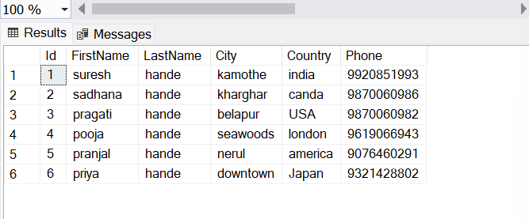

6. write a query to display Country whose name starts with A or I

SELECT *FROM Customer

WHERE Country LIKE 'a%' OR Country LIKE 'l%'

ORDER BY Country;

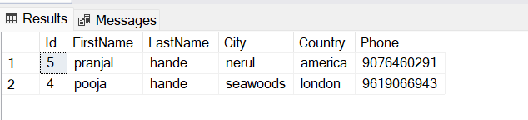

7. write a query to display whose name of customer whose third character is i

SELECT *FROM Customer

where FirstName LIKE '__i%';



1. Display the details from Customer table who is from country Germany.

update Customer

set Country='Germany'

where Id='2';

-------------------------

select *from Customer

where Country like 'Germany';

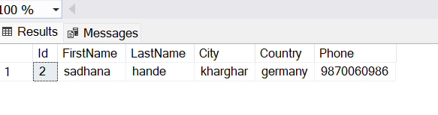

2. Display the fullname of the employee.

select FirstName + ' ' + LastName FullName from Customer;

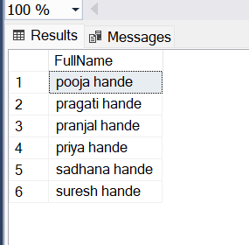

3. Display the customer details who has Fax number.

select *from Customer

where Phone like '%+1%'

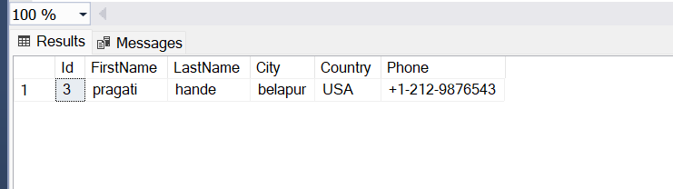

4. display the customer details whose name holds second letter as U.

select *from Customer

where FirstName like '_u%';

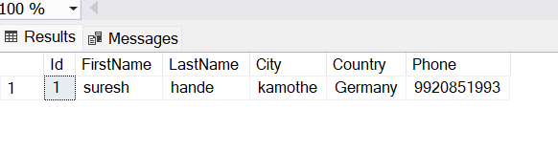

select *from Customer

where FirstName like '_u%';

5. select order Details where unit price is greater than 10 and less than 20.

update OrderItem

set UnitPrice='15'

where Id in ('333','555')

update OrderItem

set UnitPrice='12'

where Id='222'

-------------------------------------------

select * from OrderItem

join Orders

on OrderItem.OrderId=Orders.Id

where UnitPrice between '10'and'20'

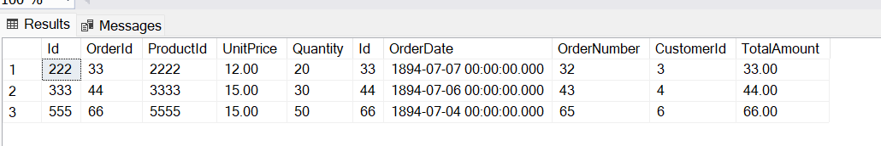

6. Display order details which contains shipping date and arrange the order by date

select *from Orders

order by OrderDate

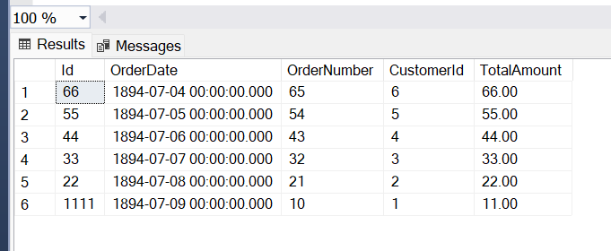

print the average quantity ordered for every product

select AVG(Quantity), * from Product

join OrderItem

on Product.Id=OrderItem.ProductId

group by Quantity,Product.Id

order by Quantity,Product.Id

1.write a query to display the orders placed by customer with phone number 030-0074321.

update Customer.

set Phone='030-0074321'

where FirstName='pranjal'

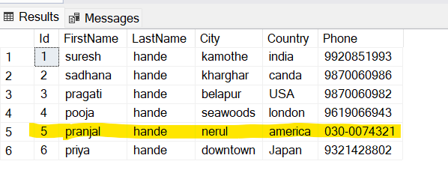

select * from Customer

where Phone='030-0074321'

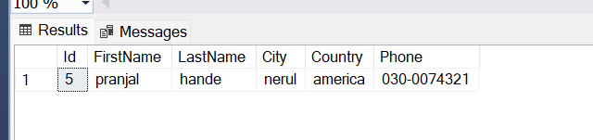

3.Display the orders placed by customers not in London.

select * from Customer

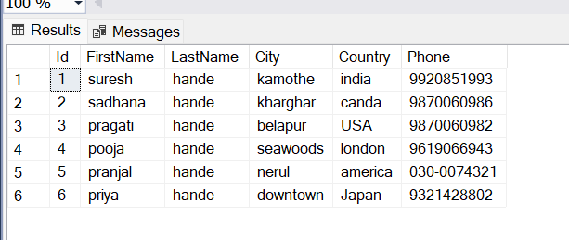

select * from Orders

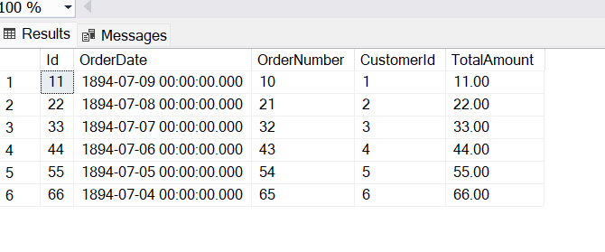

select * from Customer

join Orders

on Orders.CustomerId=Customer.Id

WHERE Country <>'london'

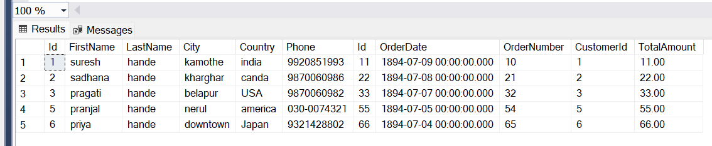

4. selects all the order which are placed for the product Chai.

update Product

set ProductName='Chai'

where Id='1111'

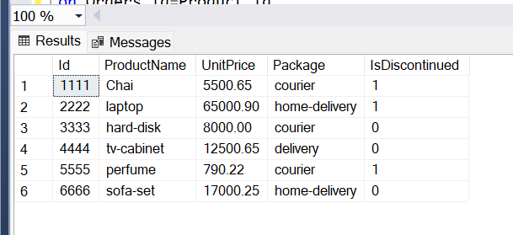

select * from Orders

join Product

on Orders.Id=Product.Id

WHERE ProductName='Chai'

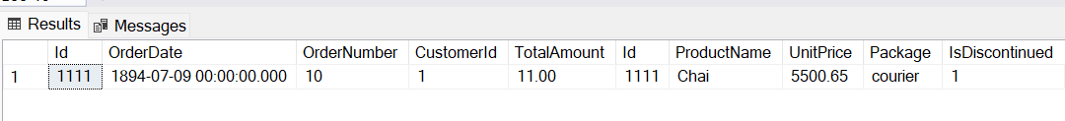

8. Display complete list of customers, the OrderID and date of any orders they have made.

select Customer.FirstName,Customer.LastName, OrderItem.OrderId, Orders.OrderDate from Customer

join Orders

on Customer.Id=Orders.CustomerId

join OrderItem

on orders.Id=OrderItem.OrderId

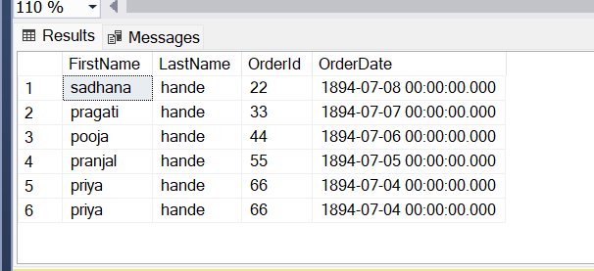

9. Write query that determines the customer who has placed the maximum number of orders

select max(OrderItem.Quantity),customer.FirstName,Customer.LastName,count(*) from Customer

join Orders

on Customer.Id=Orders.CustomerId

join OrderItem

on Orders.Id=OrderItem.OrderId

group by OrderItem.Quantity

order by count(*) desc

10. Display the customerid whose name has substring ‘RA’

select * from Customer

where FirstName like '%ra%'

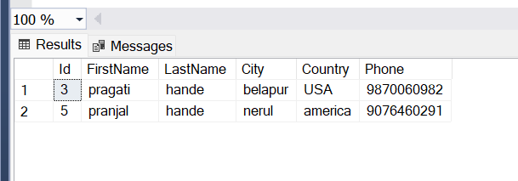

11.Display the first word of all the company name.

Alter Product

Add column Company nvarchar(50)

-------------------------------------------------------

Select * from Product

